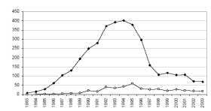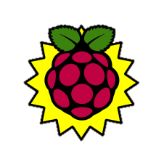

HDMI

Alert

SD-card: Csv- datalogging

PC Status

Application

Netwerk

Kabel

UART

Bluetooth

module

Serial (RS485) communication

Mastervolt

Inverter

Inverter

SMA

USB

Power-  
Supply

Router

LAN

LCD (optional)

Keyboard

& Mouse

(optional)

USBhub

Wifi

Bluetooth

USB

Ethernet

PVoutput.org